**CHAPTER FOUR**

**RESULTS**

**4.1 Sociodemographic factors of the participants**

Majority of the participants (71%) were within the age group 36-45 years, as more than half of them were female (57%) and married (52%). Most of the participants had secondary education (51%), half of them were unemployed (50%) and the majority earns between 100,000-150,000 monthly. Majority of the participants (68.5%) has been diagnosed of diabetes for the duration of 1-5 years, while majority of them (73%) do not have any complications such as retinopathy and neuropathy. See Table 4.1

**Table 4.1. Sociodemographic factors**

| **Characteristic** | **N = 200** |
| --- | --- |
| Age |  |
| >56 years | 1 (0.5%) |
| 15-25 years | 29 (14.5%) |
| 36-45 years | 142 (71%) |
| 46-55 years | 28 (14%) |
| Gender |  |
| Female | 86 (43%) |
| Male | 114 (57%) |
| Marital Status |  |
| Divorced | 1 (0.5%) |
| Married | 104 (52%) |
| Single | 94 (47%) |
| Widowed | 1 (0.5%) |
| Level of Education |  |
| No formal education | 2 (1.0%) |
| Primary | 2 (1.0%) |
| Secondary | 101 (51%) |
| Tertiary | 95 (48%) |
| Occupation |  |
| Government employee | 25 (13%) |
| Self-employed | 76 (38%) |
| Unemployed | 99 (50%) |
| Monthly Income |  |
| #100000 - #150000 | 101 (51%) |
| #20000 - #50000 | 2 (1.0%) |
| #51000 - #100000 | 39 (20%) |
| > # 200000 | 58 (29%) |
| Duration of Diabetes Diagnosis |  |
| < 1 year | 17 (8.5%) |
| >10 years | 16 (8.0%) |
| 1-5 years | 137 (68.5%) |
| 6-10 years | 30 (15%) |
| Presence of Complications |  |
| Not sure | 36 (18%) |
| No | 146 (73%) |
| Yes | 18 (9.0%) |

**4.2 The Quality of Life among the participants**

The quality of life of the participants was assessed by the WHOQOL-BREF instrument, the instrument has four domains; physical health, psychological health, social relationships and environment. The mean of each domain is calculated to give a set of raw score, the raw scores are transformed to a 0-100 scale, to make the domains comparable. See the formula below

Scoring formula

Transformed score = [(raw score – lowest possible raw score) / (highest possible raw score – lowest possible raw score)] * 100

As regard the participants’ overall health, most of them (79.5%) claimed their overall health is very poor.

The mean and SD score of the domains are presented in table 4.2 as follows: physical health (29.650 ± 9.622), psychological health (41.550 ± 12.575), social relationships (38.708 ± 7.467), environment (36.250 ± 7.242). The overall mean and SD of the quality of life in this study was 36.539 ± 4.487, see table 4.2. The quality of life was classified into severity based on the classification scheme on table 4.2.2, it was observed that majority of the participants (97.5%) moderately impaired quality of life.

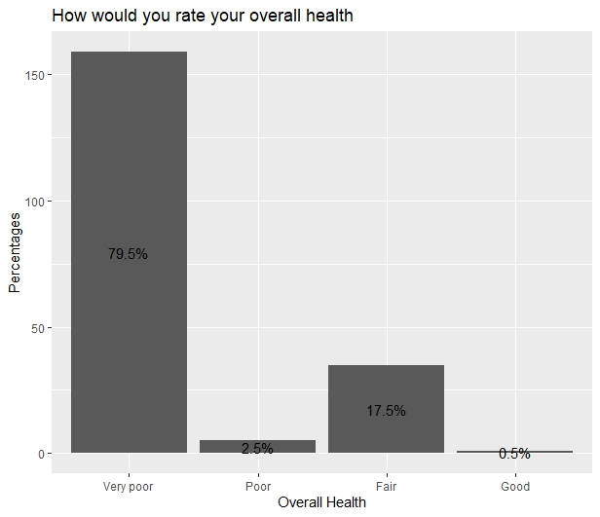

Figure 4.1 Overall health of the Type 2 diabetic patients attending the Medical Outpatient Department (MOPD) at Ahmadu Bello University Teaching Hospital (ABUTH), Zaria, Nigeria.

**Table 4.2.1: Descriptive summary of the 4 domain of the WHOBREF in the study**

| **variable** | **n** | **min** | **max** | **median** | **IQR** | **mean** | **S.D** |
| --- | --- | --- | --- | --- | --- | --- | --- |
| Physical health | 200 | 10 | 65.000 | 30.000 | 10.000 | 29.650 | 9.622 |
| Psychological health | 200 | 10 | 65.000 | 35.000 | 15.000 | 41.550 | 12.575 |
| Social relationships | 200 | 25 | 58.333 | 41.667 | 8.333 | 38.708 | 7.467 |
| Environment | 200 | 5 | 65.000 | 35.000 | 10.000 | 36.250 | 7.242 |
| Total | 200 | 23.333 | 62.080 | 36.667 | 5.940 | 36.539 | 4.487 |

**Table 4.2.2: The classification scheme for the WHO BREF Quality of Life**

|  |  |  |  |
| --- | --- | --- | --- |
| **Category** | **Range** | **Frequency** | **%** |
| Normal | 76-100 | 0 | 0 |
| Mild | 51-75 | 2 | 1.0 |
| Moderately impaired | 26-50 | 195 | 97.5 |
| Severely impaired | 0-25 | 3 | 1.5 |

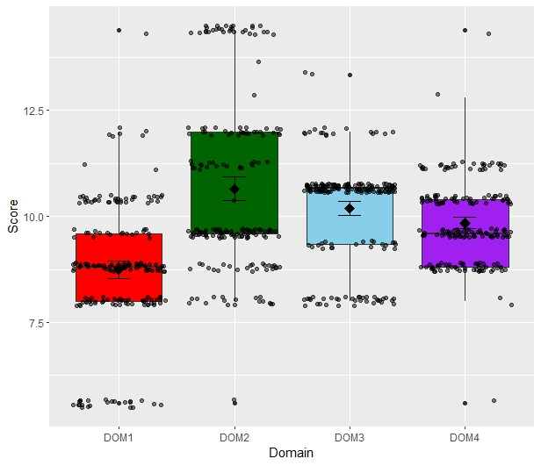

Fig 4.2 Boxplot with Jitter points of the participants in this study, DOM1 = physical, DOM2 = psychological health, DOM3 = Social relationships, DOM4 = Environment.

**4.3 The effect of selected socio-demographical factors on the quality of life of the participants**

The effect of the age, gender, level of education and monthly income on the quality of life was examined using the analysis of variance test (ANOVA) while taking significance at p-value < 0.05. It was observed that, age group had significant effect on the physical domain (0.023) and the environment domain (p-value < 0.001), gender had significant effect on the environment domain (p-value = 0.015), level of education had significant effect on the physical domain (p-value = 0.002) and the environmental domain (p-value <0.001), monthly income had significant effect on the physical (p-value = 0.001), psychological (p-value < 0.001) and the environment domain (p-value < 0.001).

4.3.1 Hypothesis

H0: There is no significant association between socio-demographic factors (age, gender, educational level, income) and the quality of life among Type 2 diabetic patients attending the MOPD at ABUTH, Zaria.

H1: There is a significant association between socio-demographic factors (age, gender, educational level, income) and the quality of life among Type 2 diabetic patients attending the MOPD at ABUTH, Zaria.

We fail to accept the null hypothesis (H0) because there were statistically significant difference/association between socio-demographic factors and the quality of life, hence we accept the alternative hypothesis H1: µ1 ≠ µ2

Table 4.3. The effect of selected socio-demographical factors on the quality of life of the participants

| Variables | Physical Health | | Pyschological | | Social Relationship | | Environment | |
| --- | --- | --- | --- | --- | --- | --- | --- | --- |
|  | Mean | SD | Mean | SD | Mean | SD | Mean | SD |
| Age Group |  |  |  |  |  |  |  |  |
| 15-25 years | 34.65 | 5.33 | 39.31 | 9.23 | 37.06 | 4.76 | 36.20 | 5.77 |
| 36-45 years | 28.94 | 9.87 | 41.44 | 13.88 | 38.73 | 8.43 | 35.14 | 7.50 |
| 46-55 years | 28.03 | 10.57 | 44.10 | 7.46 | 40.17 | 3.25 | 41.60 | 4.31 |
| >56 years | 30.00 | - | 50.00 | - | 41.66 | - | 45.00 | - |
| P-value | 0.023* |  | 0.471 |  | 0.453 |  | <0.001* |  |
| Gender |  |  |  |  |  |  |  |  |
| Female | 30.69 | 9.55 | 42.90 | 12.04 | 38.95 | 8.80 | 34.82 | 9.08 |
| Male | 28.85 | 9.64 | 40.52 | 12.92 | 38.52 | 6.31 | 37.32 | 5.24 |
| P-value | 0.182 |  | 0.186 |  | 0.688 |  | 0.015* |  |
| Level of Education |  |  |  |  |  |  |  |  |
| No formal education | 25.00 | 0.00 | 45.00 | 0.00 | 33.33 | 0.00 | 5.00 | 0.00 |
| Primary | 37.50 | 10.60 | 50.00 | 0.00 | 41.66 | 0.00 | 40.00 | 7.07 |
| Secondary | 31.98 | 9.11 | 41.03 | 11.32 | 38.36 | 8.08 | 36.53 | 5.41 |
| Tertiary | 27.10 | 9.60 | 41.84 | 14.01 | 39.12 | 6.88 | 36.73 | 6.51 |
| P-value | 0.002* |  | 0.739 |  | 0.606 |  | <0.001* |  |
| Monthly Income |  |  |  |  |  |  |  |  |
| #100000 - #150000 | 26.18 | 8.37 | 39.80 | 13.47 | 39.19 | 6.40 | 36.13 | 5.60 |
| #20000 - #50000 | 25.00 | 0.00 | 45.00 | 0.00 | 33.33 | 0.00 | 5.00 | 0.00 |
| #51000 - #100000 | 35.12 | 12.11 | 35.25 | 5.95 | 41.66 | 8.76 | 36.41 | 5.61 |
| > # 200000 | 32.15 | 7.32 | 48.70 | 11.18 | 36.06 | 7.54 | 37.75 | 6.69 |
| P-value | <0.001* |  | <0.001* |  | 0.002* |  | <0.001* |  |

*-significant at p-value <0.05

CHAPTER FIVE

DISCUSSION, CONCLUSION AND RECOMMENDATION

5.1 DISCUSSION

In terms of socio-demographic characteristics, this study included a diverse group of diabetic patients attending the medical outpatients department at the Ahmadu Bello University Teaching Hospital, Zaria, Nigeria. This study reported the majority being male (57%), within the age range of 36-45 years (71%) and were married (52%). The modal age group in this study being 36-45 years indicates that they patients were mostly late youths and young adults. The female dominance and marital status in this study corresponds to the study of Agbesanwa et al., (2023), Okwori et al. (2022) and Al-Shamiri et al., (2018). Most participants had secondary level of education (51%), the study also considered the monthly income of the participants, where majority of them (51%) earned between #100,000 to #150,000 monthly. The duration of diabetes diagnosis showed that the majority of the patients had been diagnosed about 1-5 years ago. These socio-demographic factors provide valuable insights into the characteristics of the study population and can help inform the development of tailored interventions.

The quality of life among the participants was assessed by using the WHOQOL-BREF instrument, this comprises of four domains: physical health, psychological health, social relationships and environment. This study reported the mean and SD as follows: physical health (29.650 ± 9.622), psychological health (41.550 ± 12.575), social relationships (38.708 ± 7.467), environment (36.250 ± 7.242). The overall mean and SD of the quality of life in this study was 36.539 ± 4.487. majority of the participants (97.5%) moderately impaired quality of life Nigeria carries a substantial portion (8.3%) of the global burden of chronic HBV infections (FMOH, 2016). In some study, the prevalence was as low as 6.1% in Abeokuta (Okonko et al., 2010) whereas, in the study of Olasinde et al. (2022), a prevalence of 0.8% for males and 1.8% for females in six secondary schools and a prevalence of 1.0% for children was reported in Calabar. The average prevalence rate for HBV in Nigeria ranges between 11% and 13.7%, with an estimated 20 million people chronically infected (FMOH, 2018). More recent estimates suggest that approximately 22.6 million Nigerians are infected with HBV, which translates to about 1 in every 12 people (FMOH, 2018). This high prevalence places Nigeria in the hyper-endemic region for HBV infection, indicating a severe public health concern. The prevalence in this study is slightly lower than the 9.5% prevalence found in a study some non-medical undergraduate student, Ekiti state (Elegbede et al., 2022). The variation in prevalence across these studies could be attributed to differences in the study populations and their risk factors. For instance, the study on sexually active young people focused on a specific group with potential high-risk behaviors, while the study on medical students involved a population with possible occupational exposure to the virus. Notably, the higher prevalence of HBV in the Natural and Applied Sciences faculty (58.8%) compared to the overall prevalence (8.1%) in this study is a key finding. This observation may be due to the students in this faculty having more potential exposure to blood and bodily fluids during their academic and research activities, highlighting the need for targeted interventions within specific faculties to address the disproportionate burden of HBV. This difference in prevalence across faculties emphasizes the importance of considering specific risk factors within different academic disciplines when designing prevention and intervention strategies.

The significant knowledge gap regarding HBV observed in this study is a critical concern. A majority of the participants (61.2%) were unaware of the cause of HBV, indicating a need for educational initiatives to improve understanding of the virus and its transmission. This finding is consistent with other studies that have reported low levels of knowledge and awareness about HBV among various populations 70.9% poor knowledge prevalence in Agbesanwa et al. (2023). For instance, a study conducted in Jigawa State, Nigeria, also found a low level of knowledge about HBV infection among the general population (64.9%), despite half of the respondents having attained a higher level of education (Yakudima et al., 2022). This suggests that the public education system may not be giving adequate attention to health issues, particularly infectious diseases.The importance of educational interventions in improving knowledge and awareness of HBV is highlighted by several studies. A study conducted among dental students in Saudi Arabia revealed that continued education about HBV is necessary to improve knowledge, attitudes, and practices regarding the virus (Al-shamiri et al., 2018). Another study emphasized the need for health education to be offered to undergraduates to increase the uptake of the hepatitis B vaccine (Olaoye et al., 2024). These findings underscore the importance of implementing targeted educational programs in university settings to address the knowledge gap and promote healthy behaviors related to HBV.